Going to see the GP doctor at

The Walcote Practice
Branch Surgery

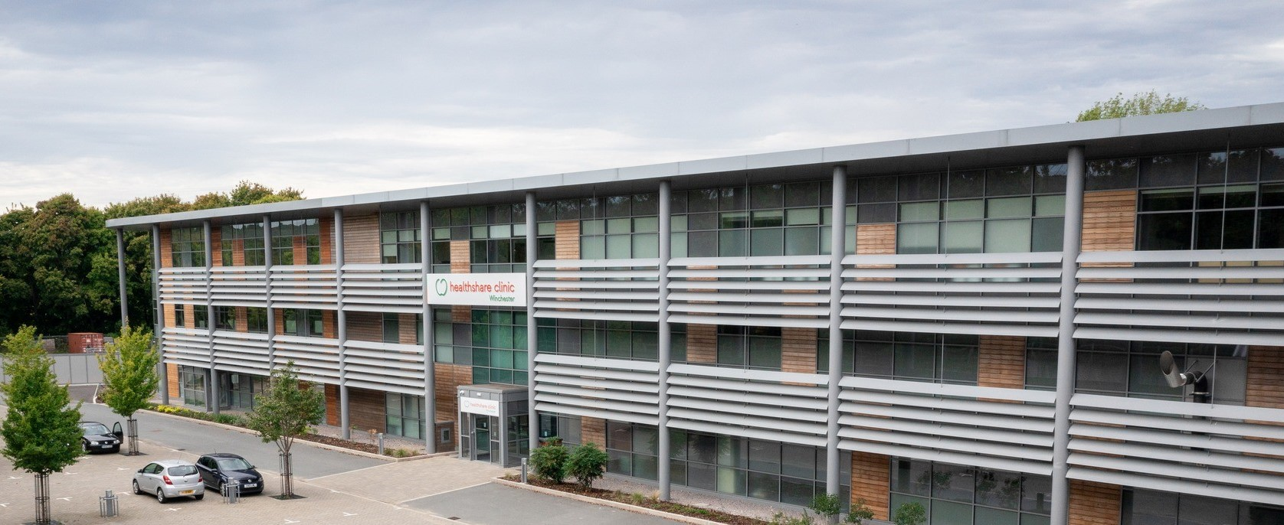

 | Our address is:  The Walcote Practice at Chilcomb Park  Chilcomb Park  Chilcomb Lane  Winchester  Hampshire  SO21 1HU

The Walcote Practice is a trading name of Walcote Health Ltd registered in England No. 08929724
Care Quality Commission registration: 1-1796565192
Registered Manager: Dr Nicholas Hillier GMC 6024661

About The Walcote Practice

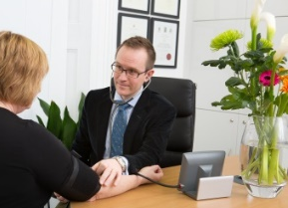 | If you are not feeling well, our doctors can help you.
 | Phone 01962 828715 to make an appointment.
Reception phones are open:

8:30am-6pm on Mondays to Fridays

9am-12.30pm on Saturdays

Branch surgery GP clinics open:

9am-5pm on Mondays to Thursdays

9:30am-6pm on Fridays

 | We have free on-site parking and disabled access.
 | The doctor can visit you at home.  Phone 01962 828715.
 | If we are closed, you can phone 111 for help.
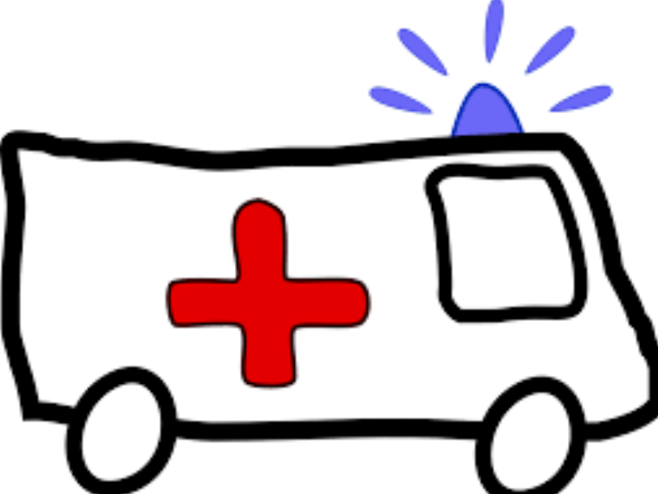 | In an emergency, phone 999.

What to do when you arrive

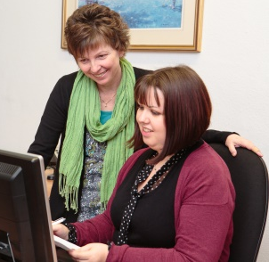 | Go to the reception desk and tell the staff that you have arrived.  They will tell the doctor.
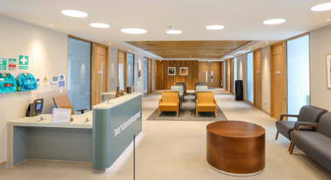 | They will show you where to sit.  Wait for the doctor to call your name.
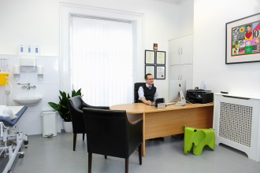 | The doctor will take you into their office.
 | Our branch surgery GP doctors are:  - Dr Nat Athaullah  - Dr Dagny Fowler  - Dr Alwin Hoelzl  - Dr Sam Phillips

Meeting with the doctor

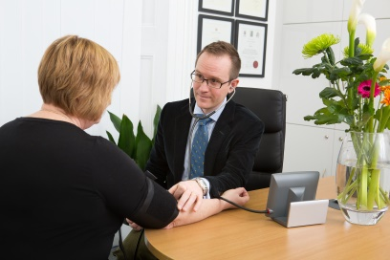 | The doctor will ask you how you are feeling.
 | They might need to examine your body to find out what is wrong.  You can ask for another person to be in the room if you like.
 | The doctor might check your weight or how tall you are.
 | Or your temperature.
 | Or your pulse or blood pressure.
 | Or your urine.

Things the doctor should do

 | Say who they are.
 | Be polite, kind and treat you well.
 | Listen to what you say and think.
 | Find out what is wrong with you.
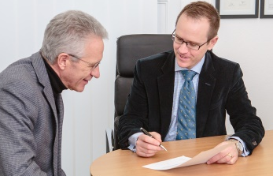 | Talk with you about the best medicine or treatment. You can say no if you want.
 | Give information in an easy way.
 | The doctor must do something if they think you are not safe.
 | The doctor may tell you to visit another health person who can help more.

Things you can do

You must go to your appointment. Phone 01962 828715 if you
cannot go.
 | Ask the doctor if you are not sure of anything. They can tell you things again.
 | You can take someone with you to the doctor if you like.
You must be polite to the staff.

Tell them if you need any support at your appointments.

 | Tell the doctor or staff if you do not feel safe. Tell them if someone else is not safe.
 | Tell the doctor if the medicine makes you ill or if you do not get better. Phone 01962 828715.
 | You can see another doctor if you want.

Information kept by doctors

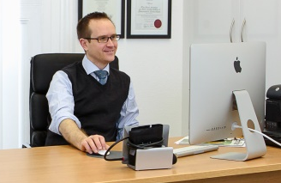 | The doctor will keep some information about your health.
 | They might share this information with other health people like doctors and nurses.
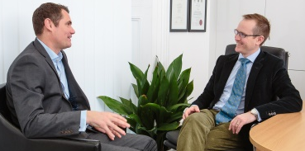 | This is to make sure that you get good care.
   | You need to pay to see our doctors.  We will record your payment.
 | Everyone will keep your information safe.
 | But speak to the doctor or staff if you are worried about this.

If you are not happy with the doctor

 | You can complain. This is when you say you are not happy with the doctor.
 | You can complain at the doctor’s Practice building.  Or you can complain on the phone. Phone 01962 828715.
 | Ask the staff if you are not sure how to complain. They will help.
 | We have an easy read leaflet and a form to help you complain.
 | The doctor will try to fix the problem.
 | Do also tell us if we did a good job.  Or tell us if we could have done something better.

