What to do if you are not happy with the doctor

 | We want you to be happy with the doctor.
 | Do tell us if we did a good job.  Or tell us if we could have done something better.
If you are not happy, you can complain.

This is when you say you are not happy with the doctor.

 | Ask the staff if you are not sure how to complain. They will help.
 | The doctor will try to fix the problem.

The Walcote Practice is a trading name of Walcote Health Ltd registered in England No. 08929724
Care Quality Commission registration: 1-1796565192 Registered Manager: Dr Nicholas Hillier GMC 6024661
How to complain

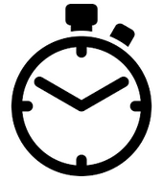 | Tell us what happened as soon as possible so we can help.
 | You can complain at the doctor’s Practice building.
 | Or you can complain on the phone. Dial 01962 828715.
 | Or you can fill in the form at the end of this leaflet with a pen or on the computer.
 | You can ask someone to help you with the questions.
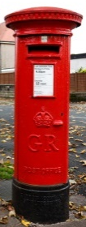 | They can post or email the form too.
 | It is fine if you are not sure about any of the questions.

Who can help you to complain

 | A family member or a friend
 | A social worker if you have one
 | The Citizen’s Advice Bureau  Phone 03444 111306
 | A person called an advocate at Solent Mind.  Phone 02380 611301
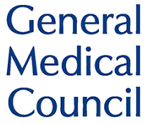 | The General Medical Council in very serious cases.  Phone 01619 236602

What will happen after you complain

 | We might ask you some more questions about what happened.
 | We will try to work out what went wrong.
 | We will tell you what we will do next.
We will try to fix the problem.

We might need to speak to other people if it will help.

Sending us the form means you agree to this.

We will let you know what happens.

We will learn lessons for the future.

The start of the form is next

Complaints Form page 1

 | Why are you not happy with the doctor or the team?  What happened?  What do you think the doctor or the team did wrong?

Complaints Form page 2

 | How are you feeling about what happened?  How could the doctor or the team make things right?

Have you told anyone else what happened? Who else was there?

Who else did you tell?

Complaints Form page 3

When did you see the doctor?
Who was the doctor?

- Dr Nat Athaullah
- Dr Olivia Buckley
- Dr Dagny Fowler
- Dr Annabel Freeborough
- Dr Nicholas Hillier
- Dr Alwin Hoelzl
- Dr Sam Phillips
- Dr Sharon Rachman

Complaints Form page 4

What is your name?
What is your phone number?

What is your email address?

Complaints Form page 5

How would you like us to reply and give you information?

Tick the red circle for all the options you prefer.

 | Using easy words and pictures? | 
 | On the phone?
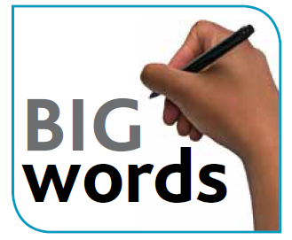 | Using big writing?
 | Using text messages?
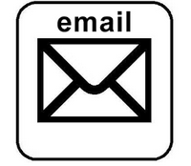 | Using email?
 | Anything else? Tell us here:

Where to send the form

 | Please put this form in an envelope
 | You need to put a stamp on the envelope
 | Write this address on the envelope:  Practice Manager  Walcote Health Ltd  Southgate Chambers  37-39 Southgate Street  Winchester, Hampshire  SO23 9EH
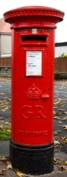 | Post the form or email it to:  info@thewalcotepractice.co.uk
 | If you have any questions then:  phone 01962 828715  email info@thewalcotepractice.co.uk  write to the postal address above

